Economic instruments for supplying agrobiodiversity conservation

**Warwick Wainwright**

Doctor of Philosophy – The University of Edinburgh – 2018

Declaration

I, Warwick Wainwright, declare that:

1. This thesis was composed by myself
2. The work contained herein is my own, except where clearly stated
3. The work has not been submitted for any other degree or professional qualification
4. Included publications are my own work

Signed: ____________________

Dated: _________________

Abstract

Agrobiodiversity is declining across global farm production systems. These declines transcend both farm animal genetic resources (FAnGR) and plant genetic resources (PGR) – the focus of this PhD. Both can sustain greater adaptability and resilience in commercial production through so called ‘option value’. In addition, PGR and FAnGR embody cultural and heritage attributes that are often absent in UK and global agriculture, but remain valued by society. Conservation is therefore important and economic incentives represent a potential supply-side mechanism to improve the status of rare breeds, cultivars and crop wild relatives. Yet, the exploration of incentive tools in the context of PGR and FAnGR remains underexplored but may improve economic efficiency and conservation outcomes. Using different survey instruments and modelling approaches (including choice modelling, linear programming and multi criteria decision analysis) I investigate how rationalising incentive support, through more targeted interventions, could result in pro-conservation outcomes. Our findings suggest optimising subsidy support relies on three key factors. First, institutional and incentive support offered to farmers for conservation should reflect local circumstances, including addressing barriers-to-entry in conservation schemes. Second, identifying least cost suppliers of conservation services may enable more diversity to be conserved at comparable cost. Third, optimising what species, varieties and breeds are supported may improve conservation outcomes through more rationalised investments in diversity. Policy responses to address declining FAnGR and PGR should consider the use of tender instruments (i.e. reverse auctions) to identify least cost suppliers for conservation services. Optimisation modelling and decision analysis techniques can be used to measure trade-offs inherent in different conservation goals and ultimately balance the use and non-use values of diversity that are supplied through the total economic value framework. While the drive for sustainable intensification of production may improve productivity, we need to be clear how breed and cultivar diversity can be encompassed into future policy priorities that reflect the need for greater food security plus cultural and heritage value attributes. The implications of deploying new and potentially disruptive technologies (i.e. gene editing) in the context of farm diversity requires further deliberation.

Graphical abstract

This should resemble the main finding from the thesis graphically. That is, incentives are needed to intervene to supply agrobiodiveristy optimally – i.e. the right locations, the right breeds / varieties / the right farmers / the right price. This requires targeting.

Good example figure here:

Esquinas-Alcázar, J., 2005. Protecting crop genetic diversity for food security: political, ethical and technical challenges. Nat. Rev. Genet. 6, 946–953.

Lay summary

Acknowledgements

I would like to express thanks to my supervisors Professor Dominic Moran (SRUC) and Professor Geoff Simm (University of Edinburgh) for all their guidance and support.

Thanks also goes too Adam Drucker (Bioversity International), Alistair McVittie (SRUC), Bouda Ahmadi (SRUC), Faical Akaichi (SRUC), Klaus Glenk (SRUC), Libby Henson (Grassroots) and Tom Beeston and Ruth Dalton (Rare Breeds Survival Trust), for their continued support and assistance with fieldwork.

I would also like to acknowledge funding for this PhD project provided by the Natural Environment Research Council (NERC) E3 Doctoral Training Programme (DTP). I also acknowledge funding from Operation Wallacea and the SADC Crop Wild Relatives Project (FED/2013/330-210) co-funded by the European Union and implemented through ACP-EU Co-operation Programme in Science and Technology. I also acknowledge the support of the Scottish Government’s Rural and Environment Science and Analytical Services Division (RESAS) funding to SRUC.

Finally, I wish to thank my family, Aaron, Hadley, Clive and Heather Wainwright for putting up with me.

Table of Contents

Economic instruments for supplying agrobiodiversity conservation 1

List of abbreviations 1

Author’s contribution to the field 1

Introduction 1

1.1 Global livestock production 1

1.2 What are Farm Animal Genetic Resources (FAnGR) 1

1.3 The importance of FAnGR 2

1.4 The state of FAnGR globally 3

1.5 Aims and objectives 3

1.6 Structure of the thesis 3

Valuing rare livestock breeds and farm animal genetic diversity: preferences, institutions and prospects 4

2.1 4

Contracts for supplying Farm Animal Genetic Resources (FAnGR) conservation services in Romania 4

Economic costs for in-situ conservation of Crop Wild Relatives (CWR) in Zambia: An application of Competitive Tender (CT) 5

Developing a prioritisation metric for conserving cattle native breeds at risk (NBAR) in the UK 5

Conclusion and recommendations 6

References 6

Appendix 6

List of abbreviations

AES Agri-environment scheme

ASC Alternative specific constant

BLP Binary linear programming

CE Choice experiment

CWR Crop wild relatives

FAnGR Farm Animal Genetic Resources

LP Linear programming

MCDA Multi-criteria decision analysis

Ne Effective population size

RPL Random parameters logit

PACS Payments for agrobiodiveristy conservation services

PES Payments for ecosystem services

WTA Willingness to accept

WTP Willingness to pay

Author’s contribution to the field

Chapter one

# Introduction

## Global agricultural production and food security

### Livestock production

The global livestock sector is estimated to account for 33% of agricultural Gross Domestic Product (GDP); employs 1.3 billion people and occupies some 30% of the planets ice-free surface (Steinfeld et al., 2007; Thornton, 2010). In developing countries, ~70% of the world’s rural poor rely on livestock for their livelihoods (Hiemstra et al., 2006). The environmental footprint of livestock production is a cause for concern and has now come to the fore of global environmental governance and climate change discourse. Since 2000 it is estimated the livestock sector alone occupied 52% of humanity’s safe operating space for anthropogenic greenhouse gas (GHG) emissions (Pelletier and Tyedmers, 2010). At the same time, global production of meat is projected to more than double from 229 million tonnes in 1999/01 to 465 million tonnes in 2050 whilst milk production is expected to grow from 580 to 1,043 million tonnes (Steinfeld *et al.*, 2007). The shift from plant-based to animal based diets has been coined the 'Livestock Revolution'(Delgado et al., 2001).

Changing consumption patterns are particularly evident in some, though not all, developing countries (Pica-Ciamarra and Otte, 2011) owing to growing populations, rising incomes and changing consumer preferences (Godfray et al., 2010). There is therefore a need to increase output to meet growing demand whilst simultaneously reducing the environmental impact per unit of livestock to avoid increasing environmental degradation (Pelletier and Tyedmers, 2010). This means increasing efficiencies per animal, whereby future livestock breeding programmes will play a pivotal role. In this context, farm animal genetic resources (FAnGR) can make a significant contribution to improving the sustainability of livestock production (Eisler et al., 2014). Underpinning rapid growth of the livestock sector is global crop production.

### Crop production

Estimates suggest croplands cover some 12.6% of the earth’s ice-free land and account for 32% of all agricultural land (Foley et al., 2011; Latham et al., 2014). Around 36% of calories produced by the world’s food crops are used for animal feed (Cassidy et al., 2013). Today, just 12 plant species provide more than 70% of all human calorific food (Frison et al., 2012). The Food and Agriculture Organization (FAO) has estimated annual global production of crops will need to increase by 60% from 2006 levels to 2050 to keep pace with rising demand (FAO, 2016). But potential yield gains are hindered by widespread land degradation, increasing water scarcity and climate change. A review of studies conducted for the Intergovernmental Panel on Climate Change (IPCC) suggests the latter will adversely affect crop yields post 2030 (Porter et al., 2014) and these impacts vary regionally (De Pinto et al., 2016). At the same time, the availability of viable crop land could be reduced by 8-20% by 2050 (Nellemann et al., 2009) and the nutritional quality of key food crops could decrease due to climate change (Myers et al., 2014).

Over the past 5 decades grain production has more than doubled, yet the amount of land devoted to arable production has increased by only 9% (Pretty, 2008). Advances in crop breeding, technological advancement and precision agriculture have all contribute to meeting growing demand. In the future, it is likely more food will need to be produced from similar, or shrinking, land availability (Godfray et al., 2010; Nellemann et al., 2009). To meet the Declaration of the World Summit on Food Security target of 70% more food by 2050, an average annual increase in crop production of 44 million metric tonnes is required, representing a 38% increase over historical increases in production (Tester and Langridge, 2010). Innovation to increase production is heavily reliant on crop breeding. But breeding goals do not solely relate to yield, and the importance of greater water- and nutrient-use efficiency, as well as tolerance to drought and salinity, is likely to increase (Tester and Langridge, 2010). The ability to grow crops in challenging environments, particularly those most affected by climate change, will require adaptive genetic resources. In this context, unexploited genetic material from land races and wild relatives will be important in allowing breeders to respond to new challenges (Maxted et al., 2011).

## The importance of agrobiodiveristy

### Overview

As formerly noted, genetic resources and advances in breeding are likely to play a key role in meeting future food security. These genetic resources come under the umbrella of ‘agrobiodiveristy’ – a debated paradigm generally referring to biodiversity for agriculture (Bàrberi, 2013). The FAO (1999) define it as “*The variety and variability of animals, plants and micro-organisms that are used directly or indirectly for food and agriculture, including crops, livestock, forestry and fisheries*”. This includes the diversity of genetic resources and species used for agri-production (i.e. breeds and varieties); non-harvested species that support food production systems (i.e. pollinators) and those in the wider environment that support agroecosystems (i.e. wild relatives) – see Figure x.

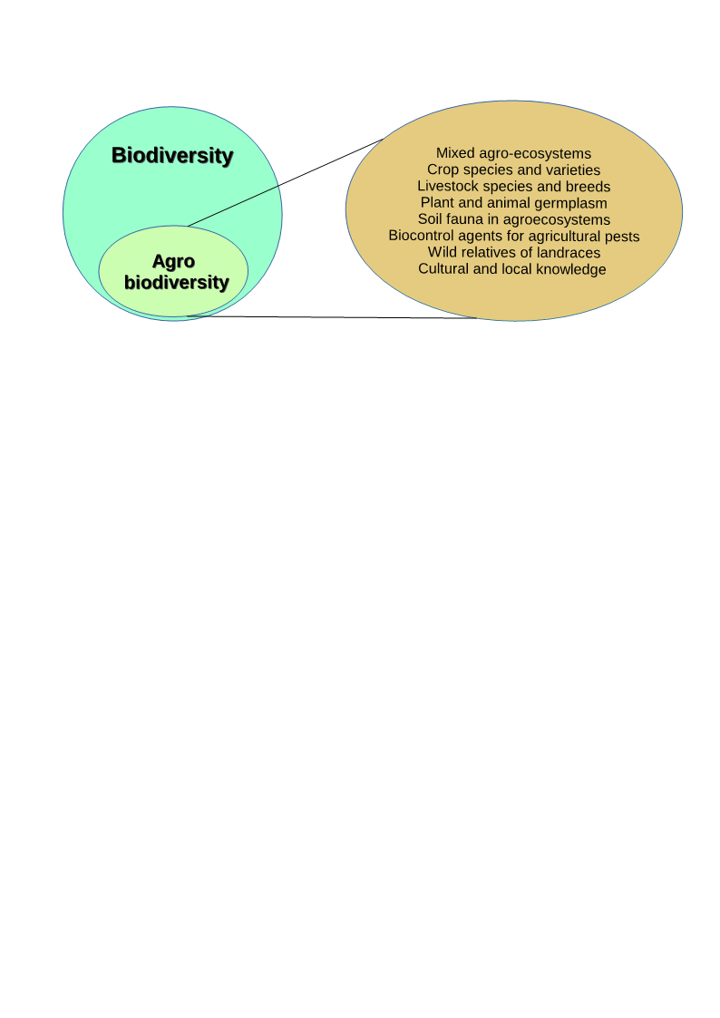

**Figure 1:** Diagram showing agrobiodiversity as a subset of biodiversity. Elements comprising agrobiodiversity are noted. Adapted from FAO, (2004)

Many market and non-market costs and benefits associated with supplying agrobiodiversity are not understood or counted when decisions about livestock breeds, cultivars or farm systems more broadly are taken. But diversity *per se* is a valuable attribute of farming systems and diverse systems are considered to be more resilient and socially desirable (Pearce and Moran, 1994). It is therefore pertinent to explore the use and non-use values associated with animal and plant genetic resources that have been most conspicuous in public policy decisions concerning the farmed countryside and farm intensification.

### Farm Animal Genetic Resources (FAnGR)

FAnGR refers to the global pool of livestock diversity that has arisen through domestication and long-standing selective breeding (FAO, 2007). Most of the approximately 40 animal species relied upon worldwide today were domesticated around 10,000 to 12,000 years ago (Simm, 1998). Many of these species originated in areas of the world now occupied by developing countries (Figure x) and were subsequently transported globally following colonisation, human migration and trade (Hiemstra et al., 2006). Today, domestic animals supply around 30% of total human food requirements, whilst only 15 animal species worldwide account for 90% of livestock production (Villanueva et al., 2004).

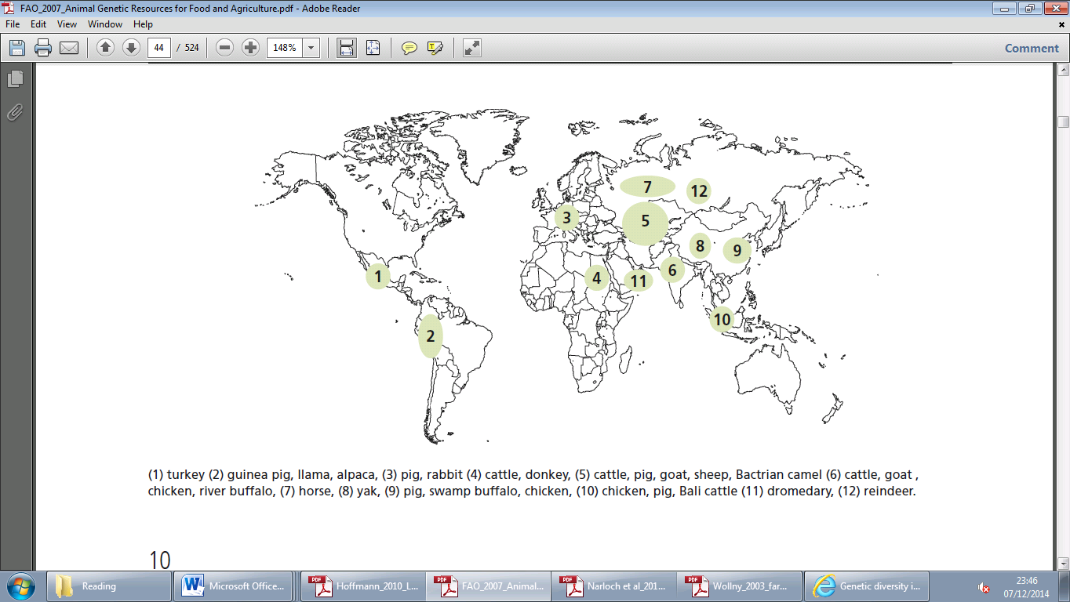

**Figure 2:** Major centres of livestock domestication (FAO, 2007)

Within species, selective breeding has resulted in high levels of breed diversity and it is estimated some 8,100 breeds[1] contribute to global livestock production (Yaro et al., 2017). Diversity within and between breeds[2] is crucial to continue adapting livestock production to meet rising demand for meat, milk and eggs (DEFRA, 2013). But breeds also serve additional direct and indirect uses (otherwise termed use and non-use values) beyond food production.

Directly, they may be used for ploughing and transport, provide manure for farm fertilisation and offer risk mitigation to rural households during epidemics and natural disasters (FAO, 2015a). Indirectly, diversity provides climate change resilience and important cultural heritage value attributes (FAO, 2015b; Gandini et al., 2010). A major argument for conservation of FAnGR is that breeds represent central reservoirs of genetic variation which allow breeders to respond to new market signals or changing environmental conditions (Mathias and Mundy, 2010 ; Pouta, 2011). It would be difficult and costly to reinstate this genetic variation if it were lost (Stoneham et al., 2010).

### Plant Genetic Resources (PGR)

PGR includes both traditional farmers’ varieties and the wild relatives of cultivated plants (FAO, 2010). Both have been used extensively in crop improvement and to great effect (Esquinas-Alcázar, 2005). PGR directly contribute to increasing food security and resilience, enhancing nutritional qualities of cultivators and reducing susceptibility of crops to drought, pests and disease (Frison et al., 2011; Rubenstein et al., 2011). Indirectly, PGR improve rural livelihoods, support the maintenance of ecosystem services including cultural values and provide adaptation to climate change (Jarvis et al., 2015; Sthapit et al., 2008). The global benefits of yield increases from crop genetic improvements range from US$ 8 to 15 billion (Frisvold et al., 2003).

Today, the genetic uniformity of many modern crop varieties has raised concerns that crop yields and production will become more vulnerable to evolving pests and diseases (Rubenstein et al., 2011). But with improved technological capabilities, these resources are becoming easier to monitor, characterise and utilise (Frison and Demers, 2014). Countries are now gaining new insights into the benefits of ensuing greater diversity as a response to growing homogenisation that reduces adaptability and increases risk. In this context, ‘temporal diversity’, changing varieties more frequently to maintain resistance to pests and diseases, is increasingly employed (Rubenstein et al., 2011).

## The state of PGR and FAnGR globally

### Threats and pressures

The importance of improving breed and crop varieties to increase production is vital. But farm intensification risks riving diversity from production systems with potentially severe consequences for agricultural sustainability. The FAO’s Global Databank for Animal Genetic Resources identified 43% of mammalian and 63% of avian breeds are classified as ‘at risk’ (Figure x). Of the 8,774 breeds recorded in the data bank, some 7, 718 are classified as local breeds (i.e. endemic to one country). This exacerbates extinction risk. The picture of breed diversity is confounded by the disparities of global reporting between regions.

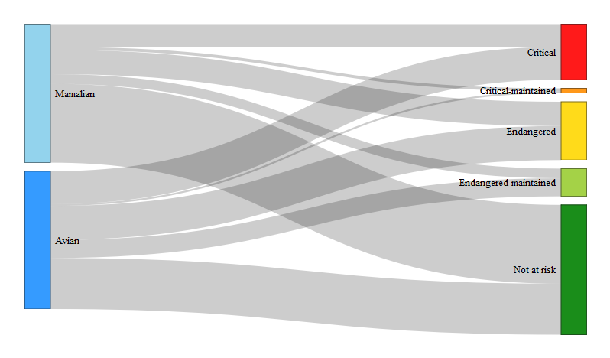

**Figure 3:** Sankey diagram of global risk status of mammalian and avian livestock breeds. The width of the nodes corresponds to the number of breeds associated with each ordered risk category. The colour scale is ordinal, relative to risk category. Risk Status data derived from FAO (2015a).

Work on farm animals suggests diversity within many breeds is declining (Groeneveld et al., 2010). For PGR declines in germplasm diversity of crops has been observed (Heinemann et al., 2014) though these findings cannot be extrapolated to commercial varieties (van de Wouw et al., 2010). Much more evidence exists concerning the occurrence genetic erosion due to reliance on a smaller subset of breeds and varieties for the majority of production. Contracting diversity, across both PGR and FAnGR, is generally borne from similar proximate threats including habitat loss, globalisation, overexploitation, political instability and intensification (FAO, 2010; Hoffmann, 2011; Yaro et al., 2017). Causative drivers of diversity loss stem from indiscriminate cross-breeding; conversion to high yielding breeds and varieties; climate change and disease epidemics (Castañeda-Álvarez et al., 2016; Sharma and Ahlawat, 2017).

The global distribution of plant and animal genetic resources is heterogeneous. Plant genetic resources were domesticated through crop wild relatives (CWR) and tend to be concentred around ‘Vavilov’ centres (Maxted and Kell, 2009). The former are centres of origin/diversity for cultivated plants and tend to be located across equatorial regions where the severity of pressures eroding diversity is growing. Similarly, the global distribution of livestock breeds and the proportion of at-risk breeds are heterogeneously distributed (Figure x). Some 70% of livestock breeds are said to be located in developing countries (Villanueva et al., 2004). These factors, combined with proximate and direct pressures, influence how we should respond to ameliorate diversity loss through two main conservation responses – *ex-situ* and *in-situ*.

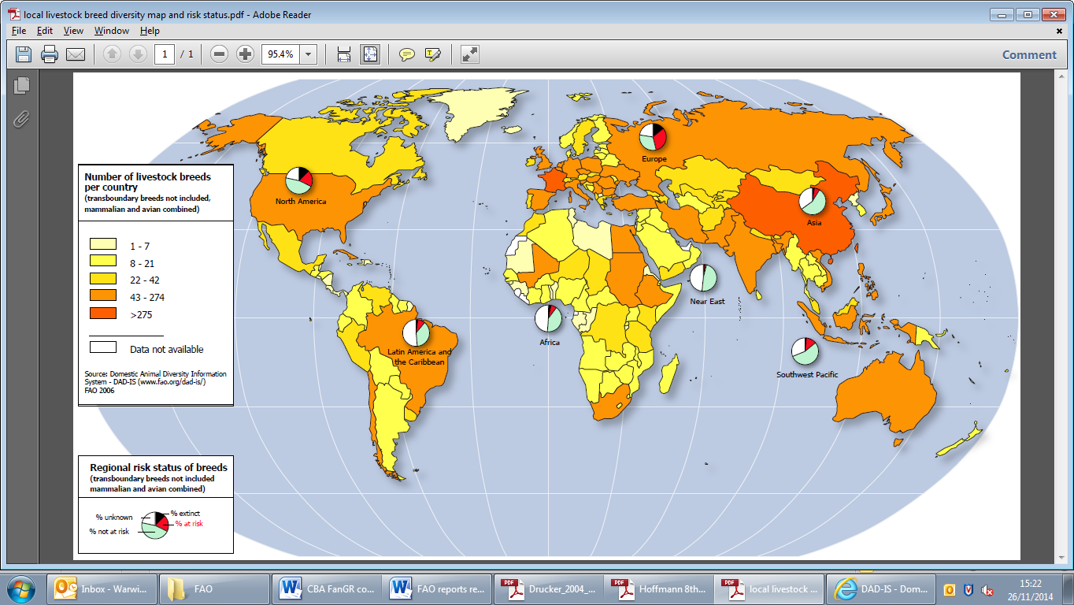

**Figure 4:** Distribution of the world’s livestock breeds and regional risk status of breeds (FAO, 2007)

### *Ex-situ* conservation

*Ex-situ* conservation generally refers to the preservation of breeds/varieties outside their natural environment. Most notably, but not exclusively, is conservation in genebanks – the collections of germplasm that are cryogenically frozen. Germplasm refers to genetic material useful for animal and plant breeding and most prominently includes semen, embryos, DNA, seeds and pollen.

Genebanks for both PGR and FAnGR are advantageous as they offer protection from disease epidemics and natural catastrophes (Boettcher, 2012). In addition, *ex-situ* offers economy of space, relatively low labour demands and, consequently, the capacity to maintain large samples at lower cost than *in-situ* approaches (Rajasekharan, 2015). But a major disadvantage is that the genetic material is unable to adapt and evolve over time (DEFRA, 2006). Thus, stored material may become redundant over time as it is superseded by *in situ* conditions. In addition, a small proportion of genetic diversity present in living populations is conveyed in ex-situ collections (Esquinas-Alcázar, 2005). Such approaches also negate the cultural and heritage value attributes of landraces.

Many accessions of both plants and animals are inadvertently duplicated, resulting in unwanted overlap and costly redundancies. There is therefore a strong case for greater rationalisation of collections through optimisation modelling, whereby maximal diversity is conserved for minimum cost. Additionally, *ex-situ* approaches are limited by technological progress in techniques to cryogenically freeze genetic material. This is particularly evident in FAnGR, where the freezing of some genetic material for certain species is still not possible (Hiemstra, 2015). Thus, while *ex-situ* offers benefits, it cannot supply all conservation needs or values. Therefore, it is often considered complimentary to *in-situ* approaches.

### *In-situ* conservation

*In situ* conservation involves the protection of ecosystems and habitats in which plants and animals of interest have developed their distinctive characteristics (Maxted et al., 2013). This includes maintenance of farm systems that support various breeds and cultivars, often through extensive, low-input systems. The advantage of *in-situ* approaches is that evolutionary dynamics of the breed or variety are maintained, thus enabling continued adaptation of the genetic material (Hoffmann, 2010). In addition, the resource can be harvested and the cultural or heritage value of the breed/variety can be realised. Although it is the preferred approach for FAnGR, *in-situ* is hindered by the costs associated with conservation, though this may be negated for some breeds by valorisation of outputs due to production characteristics.

For plants, including wild relatives, *in-situ* approaches become increasingly cost efficient where diversity ‘hotspots’ are targeted (Fielder et al., 2015) but the overwhelming majority of conservation approaches are *ex-situ* (FAO, 2010). Although there is growing recognition concerning the importance of *in-situ* measures, particularly for wild relatives, they remain limited (Hunter et al., 2012). Implementation is generally achieved through both legislative measures and the use of incentives that reward producers or land managers for conservation effort (Narloch et al., 2011). The latter have received increasing interest and uptake for plant and animal genetic resources conservation and warrant further discussion.

## Economic incentives for conservation

The use of economic incentives has received wide-ranging application in environmental policy as a means to promote biodiversity and ecosystem services conservation (Pirard, 2012). This has been particularly evident in the widespread uptake of payments for ecosystem services (PES) schemes that reward landowners for supplying public goods. PES are voluntary schemes where land managers can opt to supply a pre-defined service for a conservation payment, conditional on certain specifications agreed between the service provider and beneficiary (Helm, 2015). Such approaches generally work by offering financial incentives to encourage land managers to supply environmental services that are valued by society. This may generate both public and private benefits.

A theoretical example, framed in the context of PGR and FAnGR conservation, may provide further clarification (see Figure x). Assuming farmers are rational profit maximising individuals, producers will only farm with traditional cultivars until point ap where profitability is maximised, subject to the level of farm intensification ai. Prior to ap, it may be desirable to use traditional varieties or breeds (i.e. low-input, extensive systems). Beyond this, improved breeds and varieties are the norm but this may not be socially desirable due to genetic erosion. An intervention, in the form of economic incentives, therefore shifts the curve from ap to bp – therefore lowering the opportunity cost of producing with a traditional breed or variety whilst capturing the societal benefit (red hashed area) of supplying additional diversity.

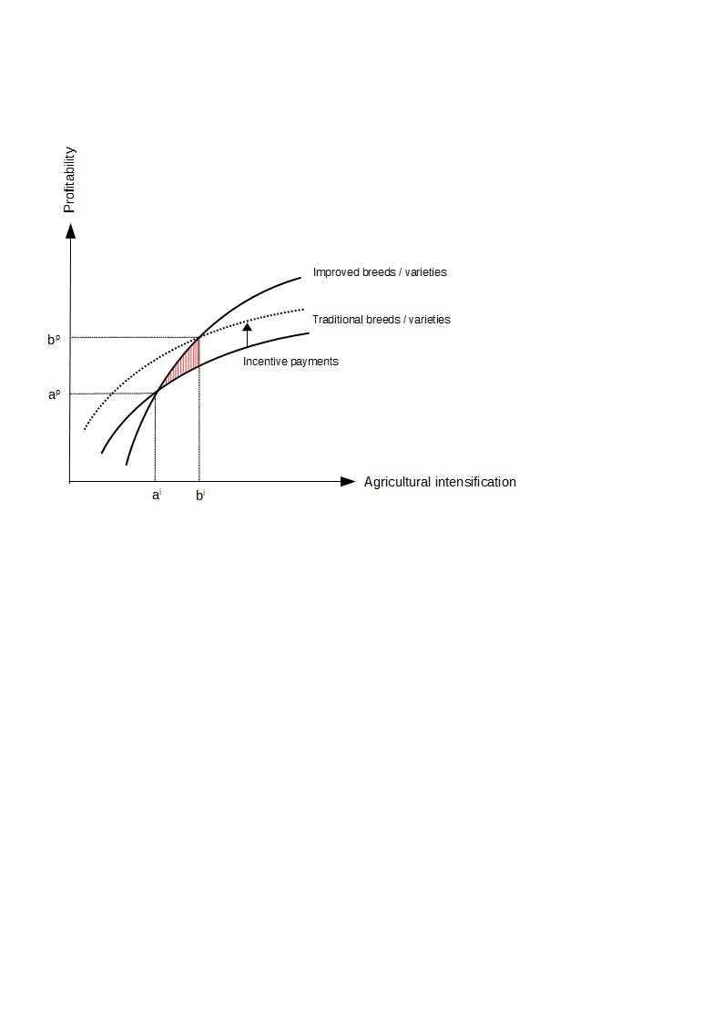

**Figure 5:** Economics of subsidy schemes to conserve PGR and FAnGR diversity. The dotted line represents the implementation of an incentive based scheme. The red hashed area reveals the societal benefit of supplying improved diversity, captured by the farmer/land manger in the form of an incentive payment.

A key advantage of direct payment mechanisms is that genetic resources which maximise societal benefits can be conserved. It may therefore prove to be more efficient than voluntary collective effort (Narloch et al., 2011). In addition, incentive schemes can be combined with diversity metrics, prioritisation approaches (Weitzman, 1998) or safe minimum standards (Drucker, 2006) for greater economic and ecological efficiency. Yet, there are relatively few examples where this is applied in practice which hampers the effectiveness of incentive schemes.

At the same time, there are concerns that economic incentives may “crowd out” intrinsic motivations, such as people's moral commitment towards nature conservation (Luck et al., 2012). Some suggest the changes incentives can induce in motivations may, under certain conditions, undermine long term conservation efforts (Kosoy and Corbera, 2010; Muradian et al., 2013). A review by Rode et al., (2015) provides evidence for both ‘crowding in’ and ‘crowding out’ effects. Additionally, the use of incentive based schemes raises broader questions concerning equitability, fairness and distribution effects (Jack et al., 2008; Narloch et al., 2013; Wunder, 2007) as well as how transaction costs are considered in scheme design.

PES type schemes have been formally adopted for plant and animal genetic resources conservation in Europe (Kompan et al., 2014; Poudel, 2015) but are relatively scarce on the global stage. For FAnGR, examples include European Commission (EC) support payments for threatened livestock breeds under Regulation No 807/2014. For PGR, a Global Environment Fund (GEF) project in Ethiopia provided funds to farmers for conserving African PGR. Most schemes provide payments to compensate yield gaps between traditional and improved varieties (i.e. opportunity cost).

There has been limited work to assess the effectiveness of incentive schemes for agrobiodiveristy conservation. Bojkovski et al., (2015) indicates multiple opportunities exist to improve effectiveness of European incentive schemes, as judged by variable breed responses. To date, no work has addressed the effectiveness of PGR incentive schemes, perhaps because so few exist.

The use of reverse auctions, or competitive tenders, has been recommended to improve cost effectiveness by identifying least-cost service providers (Windle and Rolfe, 2008). In this context, the UK Government recently affirmed its commitment to “*exploring new and innovative funding and delivery mechanisms for supplying environmental services”* (HM Government, 2018). It is therefore necessary to explore how incentive scheme design for PGR and FAnGR could be enhanced, including through better targeting, prioritisation and implementation approaches.

## Aims and objectives

The contribution of this thesis lies in the development of policy-relevant interventions that could be used to better support PGR and FAnGR conservation, in response to key challenges outlined by (Cardellino and Boyazoglu, 2009).

To date, there has been little exploration of the value of diversity (as a public good) and by extension our understanding of the incentives underlying both the supply of and demand for animal and plant genetic diversity in both developed and developing countries. Meanwhile farm systems worldwide are being homogenised in pursuit of productivity goals that are at the expense of local diversity and farm-systems resilience (Tscharntke et al., 2012).

The thesis will provide a clearer picture of the private and public good values attached to rare breed conservation and how institutions may be working to ameliorate or exacerbate farm-diversity. This is something that is conspicuously absent in developed and developing countries. Furthermore, this document improves our understanding of the likely costs of maintaining farm system diversity and the role of supply side instruments and incentives to affect (good) conservation outcomes.

The current supply of animal and, to a lesser extent plant diversity, is explored with a view to developing our understanding of the potential cost of supplying more diversity through various policy instruments. The former will broadly consider how contractual forms might be improved under existing agri environmental schemes or developed through stand-alone schemes (e.g. PES) where producers are rewarded for conservation effort. A mixture of diversity and endangerment metrics (e.g. numerical scarcity of breeding females, geographic concentration, introgression, inbreeding and effective population size) are used to illustrate how interventions that target key actors in specific farm systems can be made more efficient.

The dissertation is comprised of four studies. In Chapter 2, a review of public good characteristics associated with rare breeds is complimented by discourse surrounding how institutions are acting to exacerbate or ameliorate certain public goods values inherent in rare breeds. A number of proximate threats to diversity and issues pertaining to the use of incentive support schemes are discussed. Chapter 3 employs a choice experiment (CE) to determine farmer preferences for rare breed conservation contracts in Romania. Uptake in conservation programmes is modelled based on various payment scenarios related to farmer willingness to accept (WTA) conservation subsides. The various barriers that may reduce uptake are discussed, particularly in the context of small-scale and semi-subsistence producers where conservation arguably has a pivotal role to play.

In Chapter 4, a competitive tender, or reverse auction, is applied in Zambia to identify least cost conservation service providers for crop wild relatives (CWR). A linear programming (LP) model is used to demonstrate how selection of conservation sites and service providers can be optimised, subject to multiple diversity and equitability constraints. The appropriateness of selection under certain constraints is discussed alongside resource needs and costs for national scale CWR conservation programmes. Chapter 5 provides an application of multi-criteria decision analysis (MCDA) to determine how UK livestock breeds could be prioritised for more rational conservation decision making the reduces overlap. Ethical arguments around prioritisation are provided alongside consideration of economic efficiency and diversity metrics. Recommendations for the UK policy context are suggested. Finally, Chapter 6 outlines overall conclusions and recommendations from the thesis, along with suggestions for further work.

Chapter two

# Valuing rare livestock breeds and farm animal genetic diversity: preferences, institutions and prospects

The chapter focuses on the distinction between ‘rare breeds’ and FAnGR more generally. Highlighting the links between FAnGR and the sustainable intensification (SI) agenda, we discuss the prioritisation of efficiency objectives in the food system (and associated supply chains) over culture and heritage values. Drawing on the latter, we link this example to the case of rare breeds which often possess attributes of value not linked to production efficiency. The chapter concludes with wider discussion concerning three potential threats to rare breeds; SI, climate change and disease events. But opportunities for rare breeds, in the form of new production and market opportunities, are also discussed in the form of these three issues.

Chapter type: Review chapter

Completeness: 90%

Expected completion date: June 2017

# Contracts for supplying Farm Animal Genetic Resources (FAnGR) conservation services in Romania

The chapter explores the barriers to participate in rare breed conservation programmes for farmers in small scale systems in Romania. We use a choice experiment (CE) to determine attributes of a conservation contract that may be less or more desirable from a farmer perspective whilst also measuring WTA conservation subsides. The former are used to inform the design of contracts whilst the latter are contrasted with subsidy payment rates (Euro/head livestock/year) proposed by the EU for keeping rare breeds. We outline the probability of contractual enrolment among different farmer groups and suggest options for improving farmer uptake. The chapter discusses the importance of embedding FAnGR conservation in other policy measures linked to wider rural development policy, such as those targeting preservation of traditional agricultural systems.

Chapter type: Empirical work

Completeness: 80%

Expected completion date: Sept 2017

# Economic costs for in-situ conservation of Crop Wild Relatives (CWR) in Zambia: An application of Competitive Tender (CT)

The chapter identifies the lack of robust economic estimates concerning the costs surrounding in-situ CWR conservation. We discuss the cost implications of using different Area management options (AMOs) for conservation services and how the ‘mix’ of these might lead to fundamentally different conservation outcomes (i.e. species and diversity) and costs. The article moves to discuss the resource requirements should a national *in-situ* CWR conservation strategy be implemented in Zambia. The article concludes with a summary of wider deliberation concerning the use of PES including equitability and cost effectiveness considerations.

Chapter type: Empirical work

Completeness: 60%

Expected completion date: November 2017

# Developing a prioritisation metric for conserving cattle native breeds at risk (NBAR) in the UK

Prioritisation measures and indicators currently developed to inform FAnGR conservation planning are too data intensive and specific. Consequently, there has been low/no uptake of these indicators by governments or NGO’s to inform their conservation efforts. Using multi-criteria decision analysis (MCDA) we hope to demonstrate the benefits of developing more comprehensive policy support tools to improve genetic resources conservation, using UK cattle NBAR as a case study. The MCDA will consider a set of holistic criteria including diversity, utility and endangerment to inform decision making and the use of incentives to support NBAR. The chapter will discuss some concerns raised by participants to a recent workshop, organised by SRUC, discussing the use of indicators for NBAR conservation. These concerns explicitly related to how such metrics might be used, the potential for misuse and the need for improved communication between NBAR stakeholders and government.

Chapter type: Methodological contribution

Completeness: 30%

Expected completion date: February 2018(Hoyos, 2010)

# Conclusion and recommendations

## Conclusions

## Recommendations

## Further work

## Challenges for the future

# References

# Appendix

1. Note, the definition of a breed is contested, but in its simplest terms it refers to a recognised group of interbreeding animals of a given species, usually of fairly uniform appearance (Rajasekharan, 2015)
2. Within breed diversity refers to the genetic difference of animals in the same breed. Between breed diversity refers to the genetic difference between animals of different breeds.